IDEATION PHASE
AI FAQ ASSISTANT
Brainstorm & Idea Prioritization Template
Date | 25 September 2026 | Project Name | AI FAQ Assistant
Team ID | AI-FAQ-001 | Maximum Marks | 4 Marks

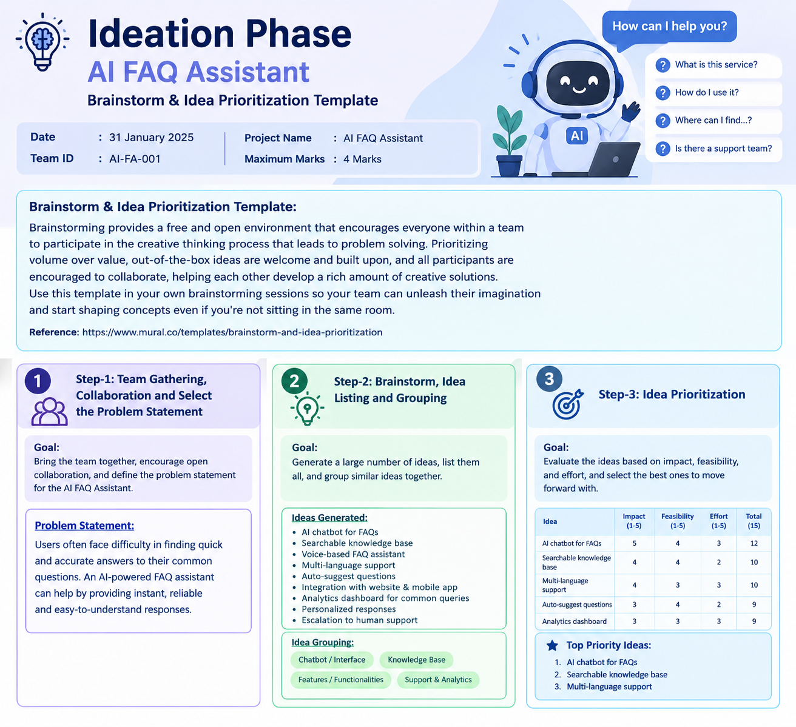
Brainstorm & Idea Prioritization
Brainstorming for the AI FAQ Assistant focuses on understanding common user questions, generating practical assistant features, grouping related ideas, and prioritizing solutions that improve answer accuracy, speed, accessibility, and user experience.
Step-1: Team Gathering, Collaboration and Select the Problem Statement
Goal: Bring the team together, identify the user need, and define the core problem the AI FAQ Assistant should solve.
Problem Statement:
Users often spend time searching through websites, documents, or support pages to find answers to frequently asked questions. The proposed AI FAQ Assistant will provide quick, accurate, relevant, and easy-to-understand answers through a conversational interface, while directing users to human support when a question cannot be resolved.
Step-2: Brainstorm, Idea Listing and Grouping
Ideas Generated:
- AI chatbot for frequently asked questions
- Searchable FAQ knowledge base
- Voice-based question and answer support
- Multi-language FAQ support
- Auto-suggestion of common questions
- Website and mobile integration
- Analytics dashboard for frequently asked queries
- Personalized responses based on user context
- Escalation to human support for complex questions
Idea Grouping:
Group | Related Ideas
Chatbot / Interface | AI chatbot, voice support, auto-suggestions
Knowledge Base | Searchable FAQ database, answer retrieval
Accessibility | Multi-language support, voice interaction
Integration | Website/mobile integration, human escalation
Analytics | Query analytics, frequently asked question reports
Step-3: Idea Prioritization
Ideas are considered using impact, feasibility, and implementation effort. Scores are on a 1–5 scale; higher total scores indicate ideas that deserve earlier consideration.
Idea | Impact (1–5) | Feasibility (1–5) | Effort (1–5) | Total
AI chatbot for FAQs | 5 | 5 | 4 | 14
Searchable knowledge base | 4 | 5 | 4 | 13
Multi-language support | 4 | 4 | 3 | 11
Auto-suggest questions | 4 | 5 | 4 | 13
Analytics dashboard | 3 | 4 | 3 | 10
Priority Focus Areas
- AI chatbot for FAQs – conversational access to common answers.
- Searchable knowledge base – organized and reliable FAQ content.
- Multi-language support – improves accessibility for diverse users.
AI FAQ Assistant • Professional Brainstorming & Prioritization

